**Lab 5 - Build your own responsive website**

In this lab you’ll be adding media-queries to your resume created in the previous lab. Use google chrome device toolbar to emulate smaller devices like phones and adjust the styles so the website still looks good. You ma consider:

* Changing font-size
* Changing flexbox direction
* Adjusting flexbox parameters and aligning text

For example your final website may look like this: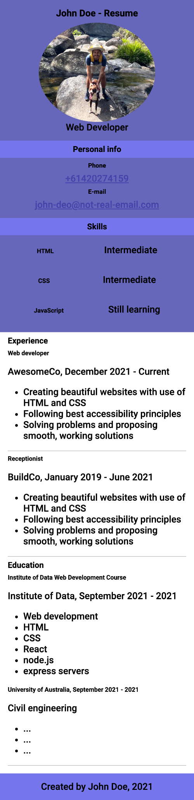

After you finish you may try to improve the looks of your website. Try to search the web for ready styling solutions. Good luck!